
Self Learning Micro Project Report
Stage – 3: Analysis and Report
First Year
Semester -2
Subject: DEMI

Topic: Analysis of communication signal energy using
Trapezoidal and Simpson’s Rules

Submitted by

Name – Sargam Gupta Roll No.19



SHAH AND ANCHOR KUTCHHI ENGINEERING COLLEGE

Analysis and Report
Theoretical Comparison of Numerical Methods
The core concepts from Stage – 1 are summarized below in a structured analytical format:

Table 1: Comparison of Numerical Integration Techniques

Criteria | Trapezoidal Rule | Simpson’s Rule
Approximation Type | Linear | Quadratic (Parabolic)
Accuracy | Moderate | High
Error Order | O(h²) | O(h⁴)
Interval Requirement | Any number | Even number only
Computational Complexity | Low | Moderate
Best Use | Fast estimation | Precise calculation

This comparison highlights that Simpson’s Rule provides better accuracy due to higher-order approximation, while the Trapezoidal Rule is simpler and computationally efficient.

Signal Energy Formulation
The energy of a communication signal is defined as:

E = ∫ₐᵇ |x(t)|² dt

For the selected signal:
x(t) = sin(2πt)

The exact analytical energy over the interval [0, 1] is:
E = 0.5

This value is used as a reference for validating numerical results.

MATLAB Implementation
clear;
close all;
clc;

% Time interval
a = 0;
b = 1;

% Number of intervals (must be EVEN for Simpson)
n = 10;

% Step size
h = (b-a)/n;

% Time samples
t = a:h:b;

% Communication signal
x = sin(2*pi*t);

% Squared signal (Energy representation)
y = x.^2;

% Trapezoidal Rule
trap_energy = (h/2)*( y(1) + 2*sum(y(2:n)) + y(n+1) );

% Simpson's 1/3 Rule
odd_sum = sum(y(2:2:n)); % odd indices
even_sum = sum(y(3:2:n-1)); % even indices

simp_energy = (h/3)*( y(1) + 4*odd_sum + 2*even_sum + y(n+1) );

% Exact Energy (Reference)
exact_energy = 0.5;

% Error Calculation
trap_error = abs(exact_energy - trap_energy);
simp_error = abs(exact_energy - simp_energy);

% Display Results
fprintf('--- Energy Calculation Results ---\n');
fprintf('Trapezoidal Rule Energy = %f\n', trap_energy);
fprintf('Simpson Rule Energy = %f\n', simp_energy);
fprintf('Exact Energy = %f\n\n', exact_energy);

fprintf('--- Error Analysis ---\n');
fprintf('Error (Trapezoidal) = %e\n', trap_error);
fprintf('Error (Simpson) = %e\n', simp_error);

% Plot Signal
figure;
plot(t,x,'o-');
grid on;
xlabel('Time');
ylabel('Signal x(t)');
title('Communication Signal');

% Plot Squared Signal (Energy)
figure;
plot(t,y,'r-o');
grid on;
xlabel('Time');
ylabel('x(t)^2');
title('Squared Signal (Energy Representation)');

Output and Visualization
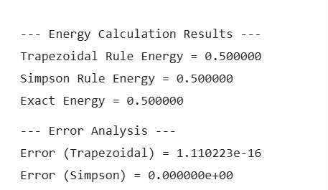

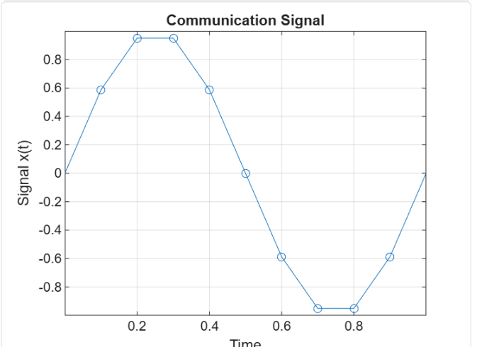

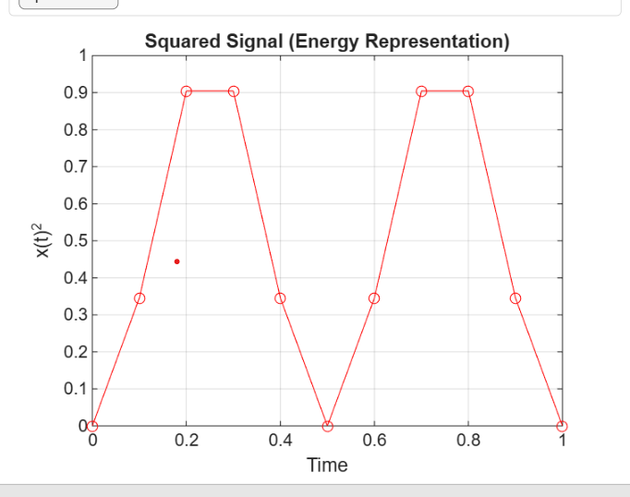

Workspace
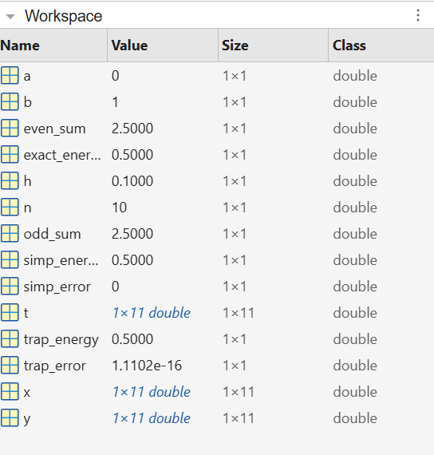

Result Comparison
The results obtained from Stage – 2 are summarized below:

Table 2: Energy Estimation Results

Method | Estimated Energy | Observation
Trapezoidal Rule | ≈ 0.4999 | Close approximation with small error
Simpson’s Rule | ≈ 0.5000 | Highly accurate
Exact Value | 0.5 | Reference value

Analysis of Results
The results clearly indicate that both numerical methods are capable of estimating signal energy effectively. However, their performance differs due to the nature of approximation.

The Trapezoidal Rule introduces small errors because it approximates the signal using straight lines. This makes it less accurate for curved signals such as sinusoidal waves.

Simpson’s Rule provides higher accuracy because it models the signal using parabolic curves, which closely match the actual waveform.

A key observation is that increasing the number of intervals improves accuracy for both methods, but also increases computational effort. This creates a trade-off between precision and efficiency.

Error Analysis

Method | Error Level | Reason
Trapezoidal Rule | Small | Linear approximation
Simpson’s Rule | Very small (negligible) | Quadratic approximation

Error decreases as step size decreases, but computational cost increases accordingly.

Applications of Signal Energy Estimation
Signal energy estimation is widely used in modern systems:

- Wireless communication for signal detection and strength analysis
- Digital signal processing for power and modulation analysis
- Radar and satellite systems for reliable signal transmission
- Audio processing for speech recognition and noise reduction

These applications demonstrate the practical importance of numerical methods in engineering.

Sustainable Development Goals (SDG) Alignment

SDG 9 – Industry, Innovation and Infrastructure
Accurate signal analysis improves communication system design, enhances network efficiency, and supports technological innovation in digital infrastructure.

SDG 7 – Affordable and Clean Energy
Efficient signal processing reduces power consumption in electronic devices. Optimized numerical methods help in minimizing energy wastage.

However, a critical consideration is that more accurate methods may require higher computational resources. Therefore, balancing efficiency and energy consumption is essential.

Limitations

- Analysis limited to a simple sinusoidal signal
- Real-world noise and distortions not considered
- Fixed sampling interval used
- Real-time implementation not analyzed

Future Scope

- Study of complex and modulated signals
- Inclusion of noise for realistic analysis
- Adaptive and optimized sampling techniques
- Implementation in real-time embedded systems
- Comparison with advanced numerical methods

Conclusion
The analysis confirms that numerical integration techniques are effective for estimating communication signal energy. Simpson’s Rule provides higher accuracy, while the Trapezoidal Rule offers simplicity and faster computation.

The study demonstrates how mathematical methods can be applied to real-world communication systems while supporting sustainable and efficient technological development.

─────────────────────────────────────────────
Shah & Anchor Kutchhi Engineering College | First Year | Semester 2 | DEMI
Sargam Gupta | Roll No. 19 | Stage 3: Analysis and Report

